TSE, Inc.

CONSUMER SURVEY REPORT
January 1 – June 30, 2018

The following is a summary report of the recently completed Consumer Surveys. This survey was developed to gather feedback from persons served by TSE and from their support team as to the quality of services received. The information will be used in future planning to ensure that the interests and needs of people are fully met.

A survey is provided at each person’s annual planning meeting, with the person and the support team collaborating on its completion. This report summarizes the feedback received from the individuals whose annual planning meetings occurred during the first six months of 2018. Thirty-six responses are represented, which is a historically low response rate for this survey. While this still provides a good statistical representation of the people served by TSE, there is an increased margin of error for these results.

The data presented represents information from those people who expressed an opinion about a specific survey item. Certain items did not apply to some individuals or the person completing the survey was not familiar enough with the area of service to respond.

Results
The overall rating for services reflected generally positive results. The percentage of people rating services as “excellent” or “more than satisfactory” was ninety-one percent (91%), a four percentage point increase from the previous report. The percentage of people rating services as “excellent” decreased by six percentage points to fifty-four percent (54%). Three percent (3%) rated services as “less than satisfactory” and none (0%) rated services as “poor”, decreases from five percent (5%) and three percent (3%) respectively in the previous report.

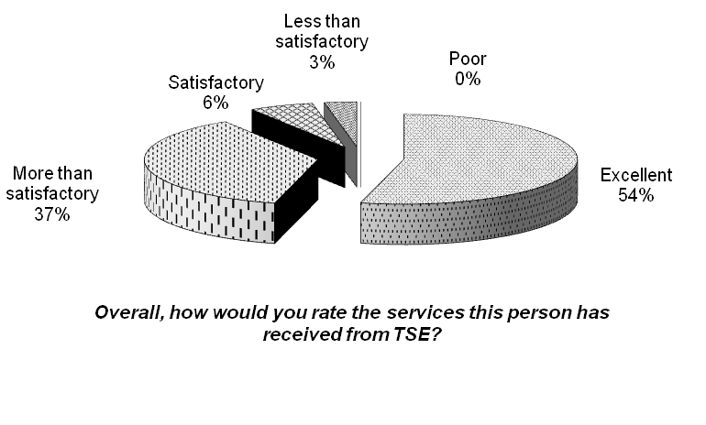

Ninety-seven percent (97%) of those responding agreed or strongly agreed that TSE provided person-centered training and supports for the person. This was a three percentage point increase from the previous report. Sixty-one percent (61%) strongly agreed, a ten percentage point increase. None disagreed, a three percentage point decrease, and three percent (3%) strongly disagreed, the same as in the previous period.

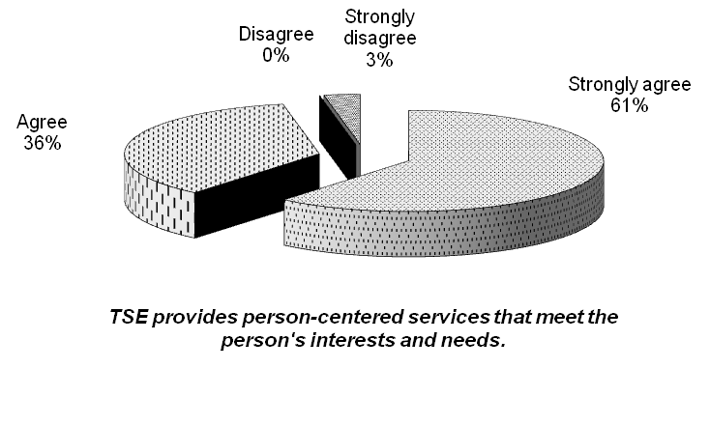
Ninety-seven percent (97%) agreed or strongly agreed that TSE provided in-house work that met the needs and interests of the person. This was an eight percentage point increase from the previous period. Forty-five percent (45%) strongly agreed, a three percentage point decrease. Three percent disagreed and none strongly disagree, both four percentage point decreases.
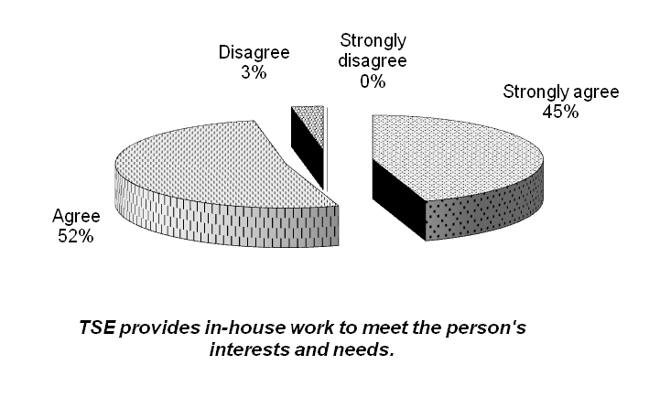

Ninety-four percent (94%) of respondents agreed or strongly agreed that TSE found a job that met the person’s needs and interests. This was at the same level as the previous reporting period. Fifty-four percent (54%) strongly agreed, a seven percentage point decrease. Three percent (3%) disagreed and three percent (3%) strongly disagreed with this statement, the same results for both from the previous period.

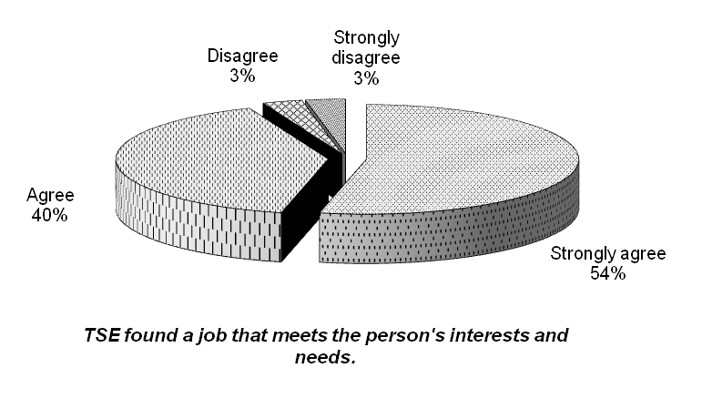

Ninety-three percent (93%) of those responding agreed or strongly agreed that TSE found a job in a satisfactory amount of time. This was a one percentage point increase from the previous period. Forty-one percent (41%) strongly agreed, a seven percentage point decrease from the previous report. None (0%) disagreed, a four percentage point decrease, and seven percent (7%) strongly disagreed, a three percentage point increase.

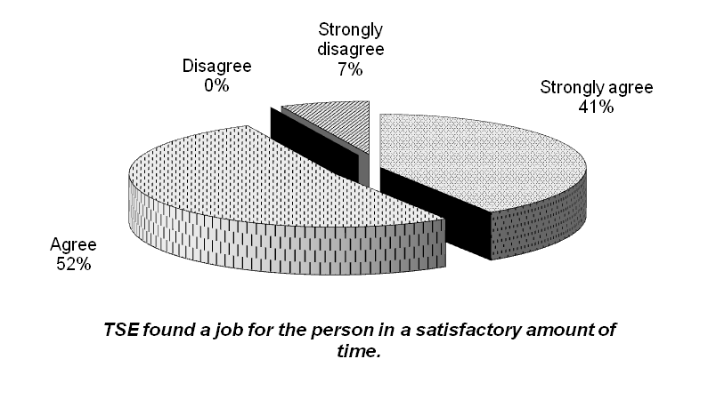

Ninety-eight percent (98%) of respondents agreed or strongly agreed that TSE provided opportunities for the person to be actively involved in the community. This was an eleven percentage point increase from the previous period. Forty-nine percent (49%) strongly agreed, a one percentage point increase. Two percent (2%) disagreed with this statement, an eleven percentage point decrease.
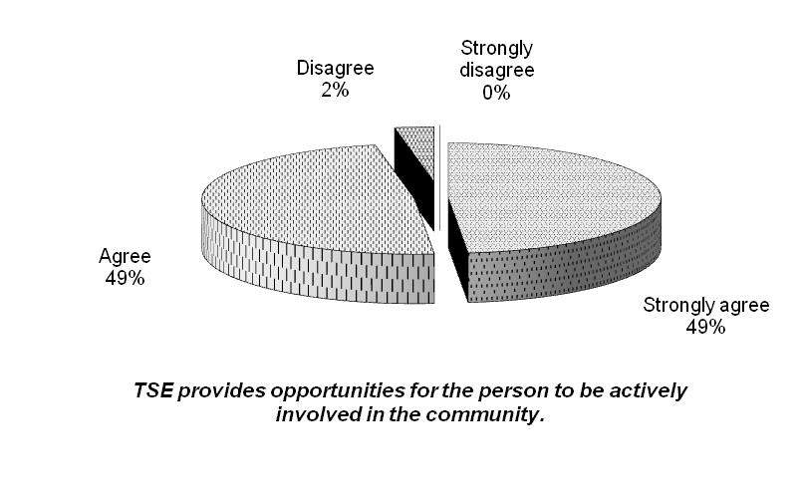

Ninety-four percent (94%) of respondents agreed or strongly agreed that TSE provided behavior supports that helped reduce the person’s negative target behaviors. This was a two percentage point decrease from the previous reporting period. Forty-four percent (44%) strongly agreed, a nineteen percentage point decrease. Six percent (6%) disagreed, a two percentage point increase from the previous report.
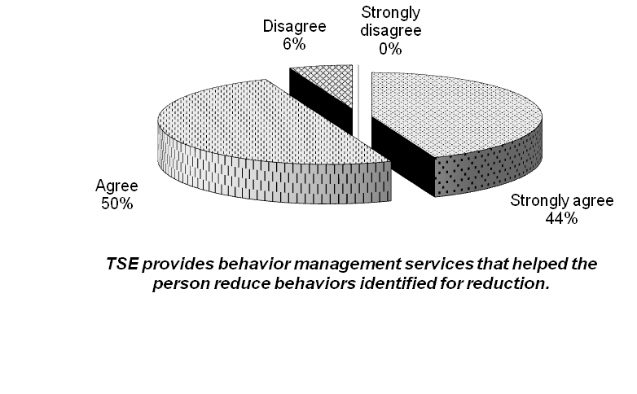

One hundred percent (100%) agreed or strongly agreed that TSE is effective in coordinating services among providers. This is a six percentage point decrease from the previous report. Fifty-five percent (55%) strongly agreed, a five percentage point decrease. None (0%) disagreed or strongly disagreed, a six and zero percentage point decrease from the previous report.
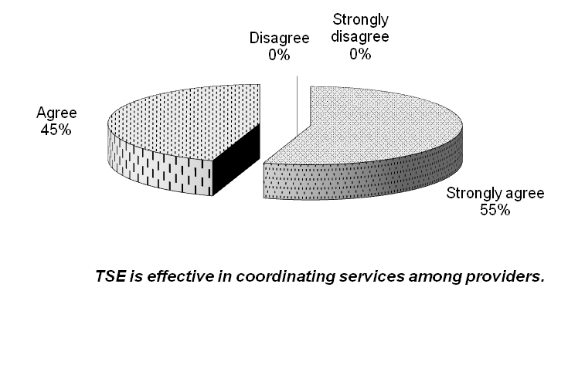
Ninety-seven percent (97%) of those responding agreed or strongly agreed that TSE staff keep them well informed regarding the person’s progress and any problems that may exist. This is the same level that was reported in the previous period. Sixty percent (60%) strongly agreed, a six percentage point increase. Three percent (3%) disagreed with this statement, the same as in the previous period. None (0%) strongly disagreed, also the same as in the previous period.
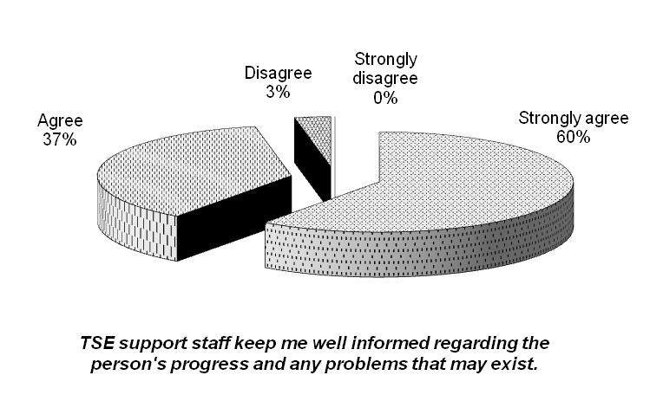

One hundred percent (100%) of those responding agreed or strongly agreed that TSE direct support professionals are respectful, courteous and professional in their interactions with the individual. This is the same level as from the last reporting period. Fifty-one percent (51%) strongly agreed, an eleven percentage point decrease. None disagreed or strongly disagreed, the same as from the previous period.
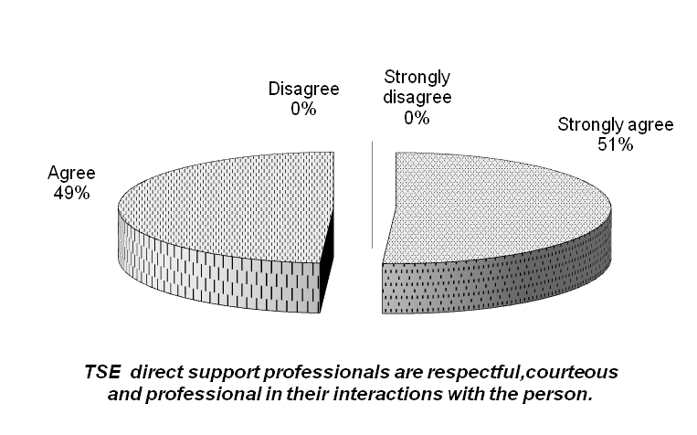

One hundred percent (100%) of those responding agreed or strongly agreed that TSE office staff are courteous and professional in their interactions and are helpful in meeting the person’s needs. This is a three percentage point increase from the previous reporting period. None (0%) disagreed, the same as in the previous report. None (0%) strongly disagreed with this statement, a three percentage point decrease.
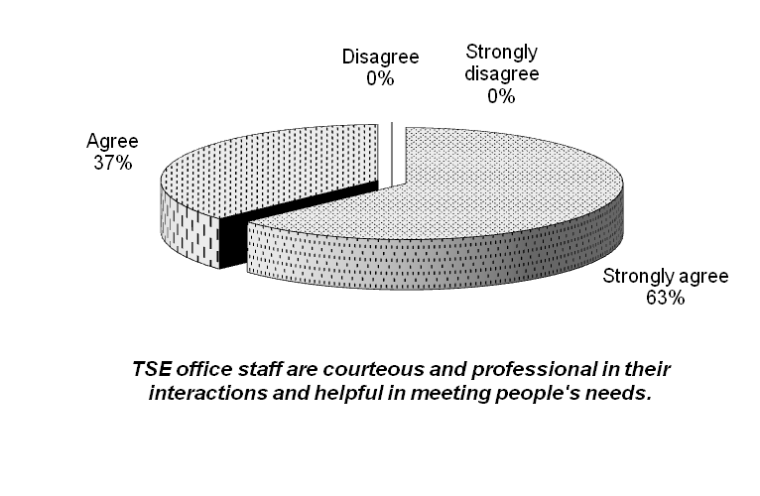
Eighty-eight percent (88%) of those responding stated that they would recommend TSE’s services to others. This is a five percentage point decrease from the previous report. Four percent (4%) said they would not recommend TSE’s services. This is a three percentage point decrease from the previous period. Eight percent (8%) had an “other” reply: one person (4%) stated “depends”, and another person (4%) stated “maybe”.
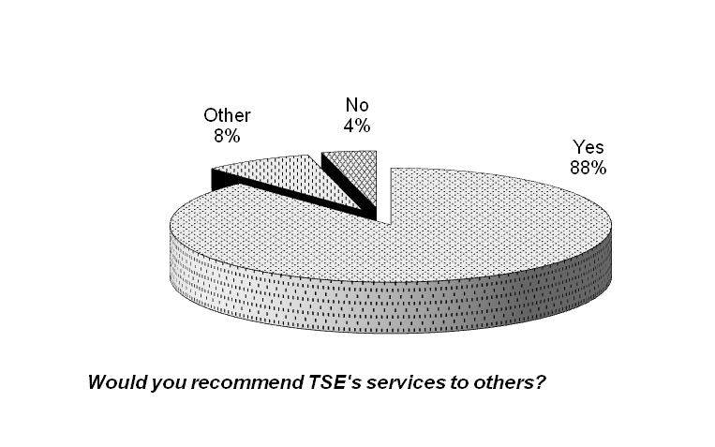

Areas of strength
Jessica S is great with < >; Mamadou; TSE provides person-centered practices and relates to < > very well; the people are very nice; work-place training; communication; empowering < > to be independent; trying to work with < >’s particular need; integration of many different special needs cases; Jill is particularly helpful and professional; communication; staff;

Areas needing improvement
Transportation; there are no jobs, communication is spotty; would like regular updates – more often than at 6 month reviews, an email would be enough; Transportation is sometimes hard to communicate with; finding jobs in the community faster;

The following trends were noted:
- Ninety-one percent (91%) rated overall services as “excellent” or “more than satisfactory”. Fifty-four percent (54%) rated services as excellent.
- Six of ten measures had 50% or higher at “strongly agree. This is lower than the previous results of seven of ten. Three measures had 60% or higher at “strongly agree”.
- Seven of ten measures had a 95% or higher rating of satisfaction (“agree” and “strongly agree” combined). This is higher than the previous results of one of ten. Three measures had 100% “strongly agree” or “agree”.
- Three measures had notable levels of disagreement – over 5%. This is lower than the four measures from the previous period.
- Three of the measures had increases in the percentage of strong agreement, compared to two measures in the previous report.

Actions to be taken:
While the overall rating of ninety-three percent (93%) and ninety-four percent (94%) satisfaction ratings for the two community employment measures is very positive, the seven percent (7%) and six percent (6%) levels of dissatisfaction need to be addressed as well. The Employment Services Department continues to excel at job placement for individuals seeking independent employment. Placement for individuals needing ongoing supports in a crew setting continue to be a challenge – a trend that has existed for several years. There has been some limited success in this area in recent months, and efforts will continue to develop the ongoing business relationships that are typically needed to create these types of jobs.

The level of success with behavior supports shows a similar result – high overall satisfaction ratings at ninety-four percent (94%), with a six percent (6%) level of dissatisfaction. TSE Management will assess the behavior support plans that are in place to ensure they are as effective as possible. Further training may be identified to continually enhance the supports in this area.

